**Preparing and Visualizing Data with Alteryx**

**by Qi Sun**

In 2012, the Massachusetts Institute of Technology (MIT) and Harvard University launched open online courses on edX, a non-profit learning platform co-founded by the two institutions. These two datasets provide data on 290 Harvard and MIT online courses, 250 thousand certifications, 4.5 million participants, and 28 million participant hours on the edX platform since 2012. The purpose of this project is to conduct a descriptive analysis on the course information by institutions, by launch years and by course subjects.

**Here is a screenshot of the workflow:**

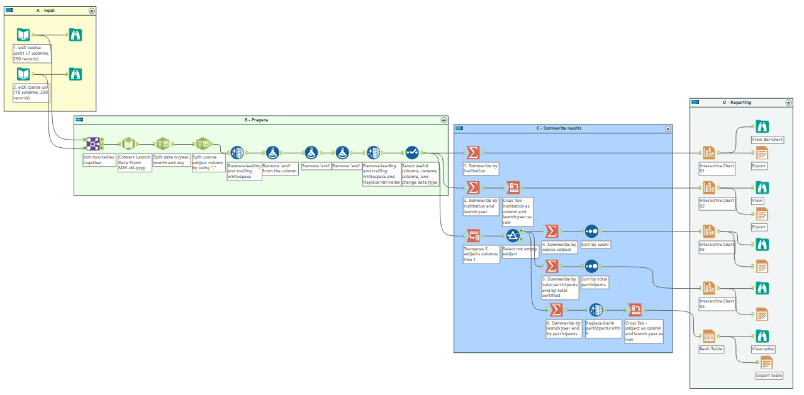

1. **The total number of courses by institution:**

As shown below, there are 129 courses run by HarvardX and 161 courses run by MITx.

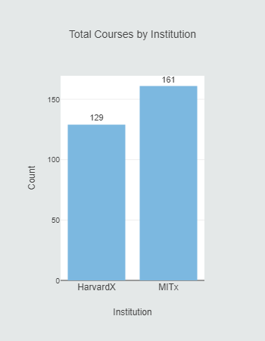

1. **The total number of courses by institution and by year:**

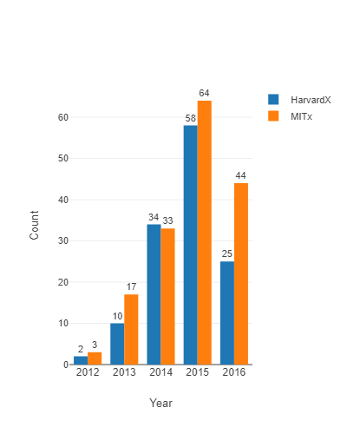

1. **The total number of courses by course subject:**

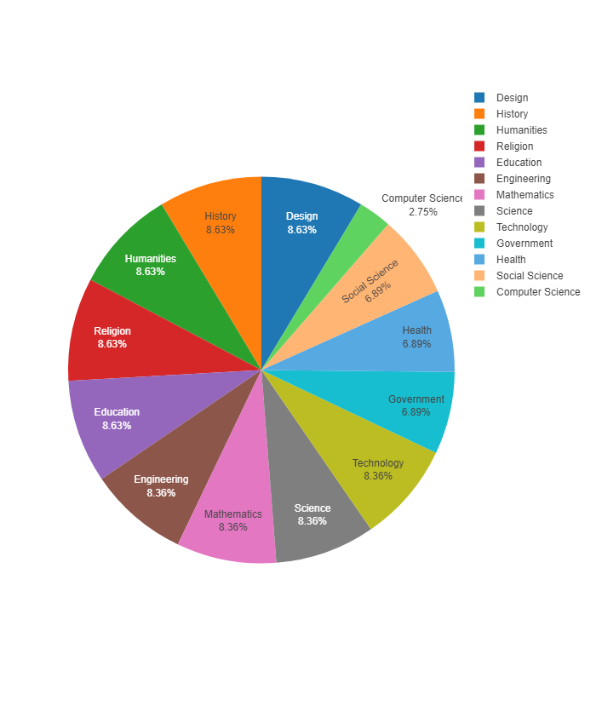

1. **The total number of participants and Certified students by subject**

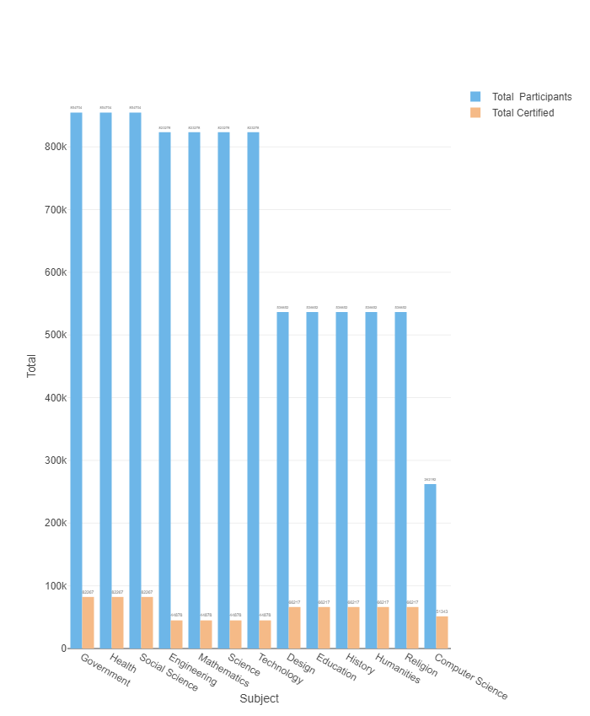

1. **The total number of participants and Certified students by subject and by year**

